Computational Electromagnetic Tools Applied to the Polarimetric Phased Array Antenna
Djordje Mirković, Dušan S. Zrnić
1. Introduction
The polarimetric phased array weather radar (PPAR) may be a future replacement of the aging WSR-88D. NOAA/NSSL and its University of Oklahoma partners are currently studying the designs and issues this new technology presents to weather observations. Two opposing geometrical designs for the radar antenna which have truly agile beam capability are: Cylindrical and Planar phased arrays. The Planar PAR is a mature technology used widely by the military, however, its use for polarimetric weather measurements is still in the exploratory stage of development. The most significant complication is the calibration of the Planar PAR which so far has not been demonstrated. The polarimetric PAR calibration is dependent on radar’s pointing direction and all of its radiation patterns. For the current generation of the planar PAR, calibration requires measurement of 8 radiation patterns: two copolar and two cross-polar both on receive and transmit. Here, we use the Computational Electromagnetic (CEM) tools for calculation of these radiation patterns. The CEM can determine patterns of the radiation elements as well as of the whole antenna. Calculated radiation patterns are expected to provide good insight into the expected performance and should predict patterns of the actual antenna. The computed patterns could be then used for the development of calibration procedures for the future planar PAR.
The PPAR should provide the same quality of polarimetric data as the WSR-88D. Thus, the requirements for PPAR are defined by the existing network. The mode of operation on the WSR-88D is simultaneous transmission and reception of the horizontally (H) and vertically (V) polarized electric fields. This mode is designated as the SHV and the alternate transmission is designated as AHV. The SHV mode enables accurate estimation of the polarimetric variables at the lowest elevation scans where the PRT is long (~3 ms). Thus, the reflectivity factor Z, differential reflectivity Z_{DR}, differential phase Φ_{DP}, and correlation coefficient (between the H and V received fields) ρ_{hv} are free of range ambiguities. At such long PRTs, the polarimetric variable estimates in the AHV mode have unacceptable errors (Zrnic, et al. 2006). At moderate PRTs (~1 ms or so) the errors in the AHV mode are acceptable hence this mode might be useful at higher elevations. Although the polarimetric characteristics of the dish antenna are fixed the effects on the polarimetric variables in the two modes are dramatically different.
The polarimetric properties are routed in two physically different sources. One is the antenna. Its copolar and cross-polar patterns can cause significant bias in polarimetric variables. The other is the hardware behind the antenna (backend). The copolar patterns need to be matched to better than 2 dB at the 20 dB level bellow beam peak (Appendix A) and the cross-polar pattern should be over 45 dB below the Copolar pattern to achieve acceptable biases in the SHV mode. Similar values apply to the Copolar and Cross-polar performance of the hardware.
For polarimetric measurements the differences between Copolar patterns ($f_{hh}$and $f_{vv}$) and gains ($G_{h}$ and $G_{v}$) are crucial in determining the Z_{DR}. Although the differences between patterns bias the ρ_{hv} estimates, no attempts are made to correct these. Rather, knowing these differences one can gage the limits of the bias. Normally, the quality of ρ_{hv} estimates is checked on data from rain and values in excess of 0.99 are considered good. Yet, the required Z_{DR} bias in the WSR-88D network is less than 0.1 dB, and the Φ_{DP} bias should be less than about 4º (see discussion after eq. 11 in the appendix B).
Measurement of the polarimetric variables on the PAR is fraught with problems. One significant issue is the dependence of the polarimetric variables on the pointing direction. An additional important issue is that the fields transmitted by the port 1 (intended H) and port 2 (intended V) are not orthogonal unless the radiators attached to port 1 and the ones attached to port 2 inherently radiate orthogonal fields in all directions. This, for example, is theoretically possible if the H radiators are magnetic dipoles or current loops, and the V radiators are electric dipoles. Such PAR has never been developed, as there are no proven effective and inexpensive solutions. The mature and inexpensive radiator technology is the patch antenna. This technology is on the ten-panel demonstrator (TPD) developed by Lincoln Laboratory and being tested by NSSL. Thus, this report aims to predict the polarimetric characteristics of the TPD and possibly guide calibration of the polarimetric variables.
Antenna array theory states that the pattern of the array is a product of the element pattern with the array factor.
$G=AF∙G_{element}$ (1)
Equation (1) successfully approximates the beamwidth and sidelobe levels of the antenna but to our knowledge is not a proven predictor of differential characteristics. This is because coupling between array elements, edge effects, and other physical characteristics of the antenna structure affect the radiation pattern. As an example, the specified Z_{DR} bias of 0.1 dB calls for precise beam and gain matchings in all directions.
It is known that patch antenna radiators (as well as many other) produce orthogonal fields in the principal planes of an array (Zhang 2009). This simplifies calibration in principal planes to multiplicative corrections of Z_{h} and Z_{dr} and no correction of ρ_{hv} and Φ_{DP} (Zrnic and Mirkovic 2018). Still, the multipliers depend on the pointing directions within the principal planes. Determining these multipliers in practice is not trivial.
Pattern measurement in the principal plane can produce the correction multipliers. Some measurements of the TPD are made in the near field and over parts of the array. The results were combined to produce a few patterns. Measurements of some patterns have also been made in the field (improvised antenna range). Neither of these has sufficient accuracy or span of directions to be adequate for calibration.
The purpose of this report is to explore the use of Computational Electromagnetics for predicting patterns of the TPD as well as the polarimetric bias. The remainder of the document is organized as follows:
- Patterns of individual patch antennas are computed. Patches are considered in two configurations: standalone and embedded within an 8 by 8 array. CEM results are compared with measurements to establish the CEM’s credibility.
- The 8 by 8 element panel is considered next. Broadside, as well as beam steering patterns, are computed and comparisons with some scant measurements. Following this, the effect of the radome is considered. Antenna performance is evaluated for the dry and water covered radome (TPD by observations at vertical incidence.
- The Ten Panel Demonstrator (TPD) model is developed and results of polarimetric biases for one principal plane are exhibited. Effects of the antenna radome are evaluated on the TPD model.

2. Patch antenna
The radiating element of the PAR is the stacked patch antenna. The patch consists of three layers where,
- first layer: radiating patch is on top of this layer
- second layer: (capacitive) coupled patch is on top of this layer
- third layer: element protective layer.
Overall, patch dimensions are 50.8 mm by 50.8 mm and the layers are made of Nelco N4000, Rohacell 71HF and Nelco N4000 materials. Fig. 1 shows the single patch model with four ports used in pairs for differential excitation of the horizontal (H) and vertical (V) polarizations. Highlighted in yellow in Fig.1 is the thin element protective layer that must be included in element modeling.
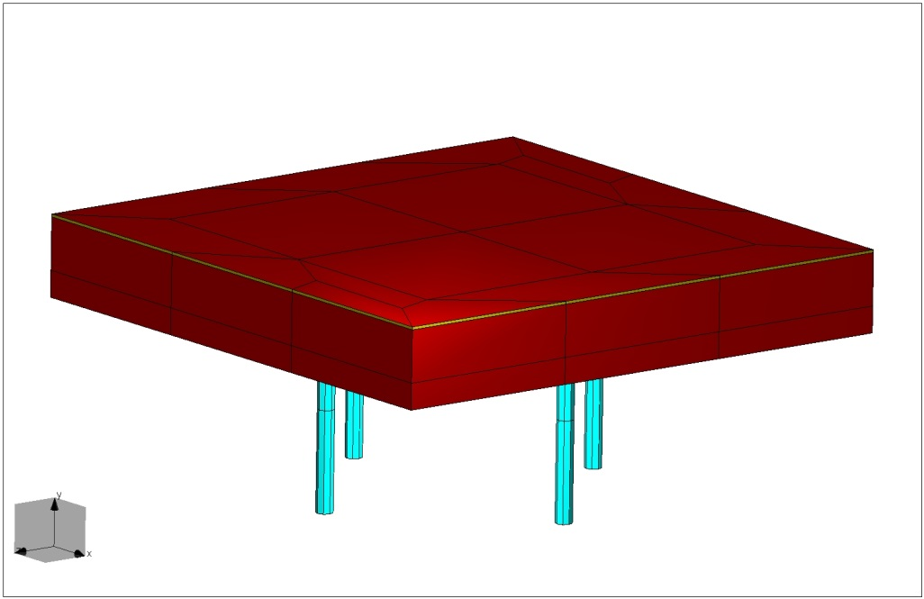
Fig. 1. The TPD stacked patch radiation element with four probes for the differential feeding of two polarizations and third (protective) layer in yellow.
The protective third layer, besides playing an important role in keeping the soft Rohacell substrate intact, affects the differential gain $F_{diff}=\frac{{\left|f_{hh}(ϕ)\right|}^{2}}{{\left|f_{vv}(ϕ)\right|}^{2}}$. Illustration how differential gain changes due to the protective layer is in Fig. 2 where two models are compared. One includes the protective layer (LL element) and the other one does not (GTRI element). Besides the apparent difference in the differential gain values at the 45º from the broadside, an offset at the broadside is also present.
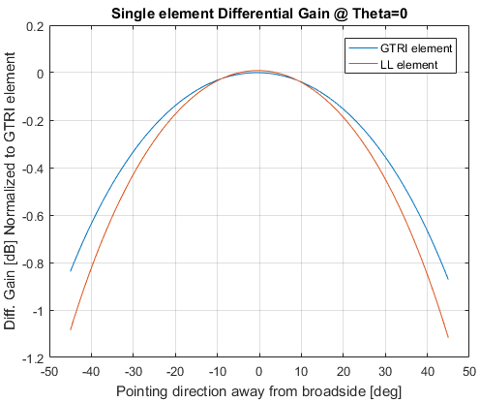
Fig. 2. The differential gains of radiation element with a protective layer (LL the actual element) and without the protective layer (GTRI model element).

3. The TPD panel (8x8 elements) model
The main assembly part of each PPAR antenna is a panel of radiating elements. The TPD consists of ten panels, each of which contains 8 by 8 radiation elements with no spacing in between. This section describes the creation of the TPD’s panel model, its evaluation against the measurements and finally, discussion of simulated results. The panel is on a single piece of material where the linear distance between element centers is exactly equal to the element width (50.8 mm). The panel has a total of 256 ports, and all non-excited ports are load matched. Patterns for each polarization are modeled separately to evaluate the full polarimetric characteristics of the antenna.
3.1 The panel model compared to measurements
Evaluation of the simulated panel models is through comparison with measurements of the Lincoln Laboratory (LL) manufactured panel. The panel consists of 64 elements, out of which only the central 2 by 2 array is excitable. All of the non-excitable ports are load matched. However, four central elements are single polarized with polarization setup as in Fig. 3.

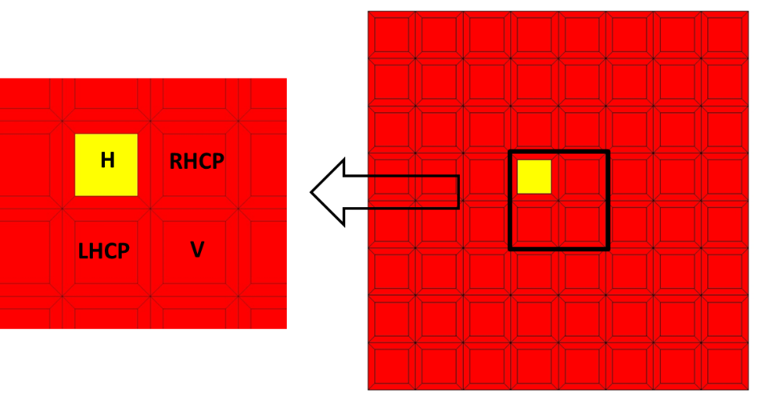
Fig. 3. The model of Lincoln Lab provided the panel with only four central elements excitable and their designated polarizations. The excited element is highlighted in yellow.
The panel was measured in cooperation with the University of Oklahoma in the anechoic chambers of the Advanced Radar Research Center (ARRC) by CIMMS/NSSL personnel. Voltage antenna patterns for each polarization were measured. Radiation phase pattern measured as the argument of the voltage pattern includes the position bias, as the antenna supports are not aligned with the axis of rotation. The radiation patterns are evaluated at three plane cuts: the E-plane (plane where the designated polarization and the cut plane are parallel); the H-plane (where the designated polarization E-field is orthogonal to the plane of measurement); and the D-plane (plane at 45º to both fields of the designated linear polarization). In each of the three planes, copolar and cross-polar (X-pol) radiation patterns were measured. Measurements in each plane reveal specific features of the antenna; ripples in the main lobe are expected in the E-plane, whereas good agreement between the two patterns in the D-plane is especially important for the cross-pol comparison, as the cross-pol is the highest in this plane.
Finally, as the panel is geometrically symmetric only H polarization results are presented, the V polarization patterns in the orthogonal plane would be very similar. The comparison of the H-pol E-plane results is shown in Fig.4. In the figure, copolar patterns are drawn using solid curves while cross-polar patterns are in dashed curves. The copolar patterns agree very well, the cross-polar patterns, especially in the main lobe direction show an angular offset. The offset in the E-plane is acceptable as the cross-polar component is more than 25 dB below the copolar component and is easily masked by the measurement biases (i.e. cross-pol of the probe).
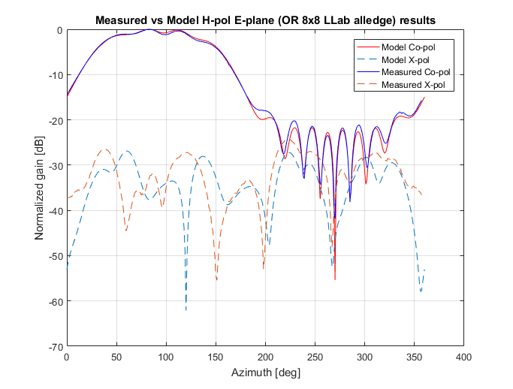
Fig. 4. Simulated and measured patterns at H-polarization, E-plane (horizontal plane). Copolar patterns are drawn with solid curves, whereas the cross-polar patterns are drawn as dashed curves. Copolar components are in good agreement whereas the cross-polar components on the average agree in magnitude but from about 0 to 160 degrees are offset in phase.
Comparison of the H-polarization in the H plane (vertical plane) is in Fig. 5. Similarly to Fig. 4, we see very small discrepancies in the copolar patterns. Cross-polar patterns exhibit some magnitude discrepancy and angular offset in the main lobe region. As the cross-polar pattern is more than 30 dB below the copolar, similar to the previous case (Fig. 4), these discrepancies are most likely caused by the probe bias and some anechoic chamber imperfections (reflections).
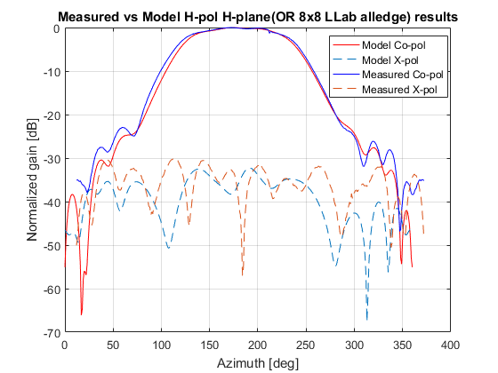
Fig. 5. Similar to Fig. 4 but patterns are for H-polarization, H-plane (vertical plane). Copolar patterns are drawn with solid curves, whereas the cross-pol patterns are plotted as dashed curves.
In the diagonal plane, the cross-pol levels are highest and can be used to benchmark the cross-polar pattern model. In the region where the sidelobes of the cross-pol pattern are larger than the copolar one's comparison of the model with the measurement is most trustworthy because the contamination by the sidelobes of the copolar pattern is minimized. The results in Fig. 6, with copolar patterns in solid, and cross-polar in dashed curves reveal this behavior. In the diagonal plane, (Fig. 6) the discrepancy between cross-polar patterns and measurements is significantly smaller than in the previous figures (Figs. 4 – 5), and the slight difference may be attributed to the limited precision of the antenna roll mechanism.
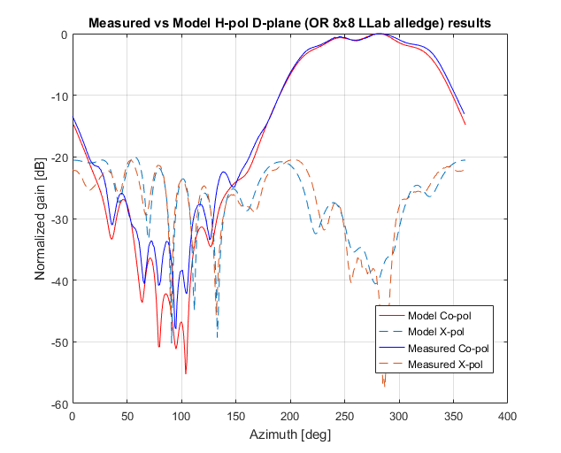
Fig. 6. Simulated and measured H-pol, D-plane (diagonal plane) patterns. The copolar patterns are drawn with solid curves, whereas the cross-polar patterns are drawn as dashed curves.
For completeness, Fig. 7 depicts the H-pol, E-plane phase measurement. The measured radiation phase pattern is biased by the changing distance between the measurement probe and the panel under test, as the panel supports were not centered on the axis of rotation. This caused the antenna to be closest to the probe at broadside and furthest away when pointing opposite broadside.
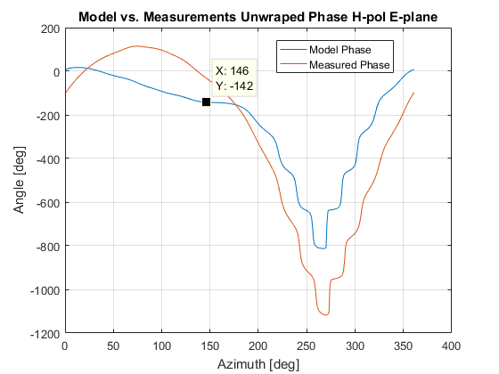
Fig. 7. The H-pol, E-plane radiation phase for copolar components of the electric field. The discrepancy between the simulated and measured field is caused by the antenna support that was off the rotation axis and thus changed the distance between the antenna and the measuring probe as the structure rotated.
The conclusion from the results in Fig. 4-6 is that the CEM modeling using the WIPL-D software can reliably and accurately simulate the TPD antenna panel.
3.2 Comparison with other software packages
Modeling capabilities available at the NSSL are optimized for large antennas. The software used within the NSSL is a Method of Moments CEM solver WIPL-D Pro. Nevertheless, the NSSL in collaboration with the Advanced Radar Research Center (ARRC) at the University of Oklahoma tested other CEM antenna modeling software. The single panel model, developed for comparison with measured patterns, was also simulated using HFSS and CST CEM software packages by ARRC collaborators. Thus, a comprehensive comparison of all solvers against measured (considered true) results could be conducted. Besides the accuracy of obtained results, simulation time for each of the solvers is compared in Appendix C.
3.3 The TPD panel model with all elements excited
In the previous section, the panel was modeled with only one central element active; in this section, the same model with all elements excited is considered. As in the previous case, separate models are created for each polarization while non-excited elements (of opposite polarization) are load matched.
Fig. 8. The TPD panel model with all 64 elements exited.
The panel model (Fig.8) is designed for evaluation of the radiation patterns at broadside as well as all beam steering angles. The beam steering function is programmed into the model by changing excitation phases to achieve the requested steer angle. Evaluation of the model’s precision is done by comparison with results provided by the LL (MIT) in the 2012 report (MIT Lincoln Laboratory 2012). Radiation pattern figures for the transmitting array are found in the “Uncalibrated Antenna Patterns and Aperture Holograms, Boresight Scan” section and compared to model results in Figs. 9 and 10.

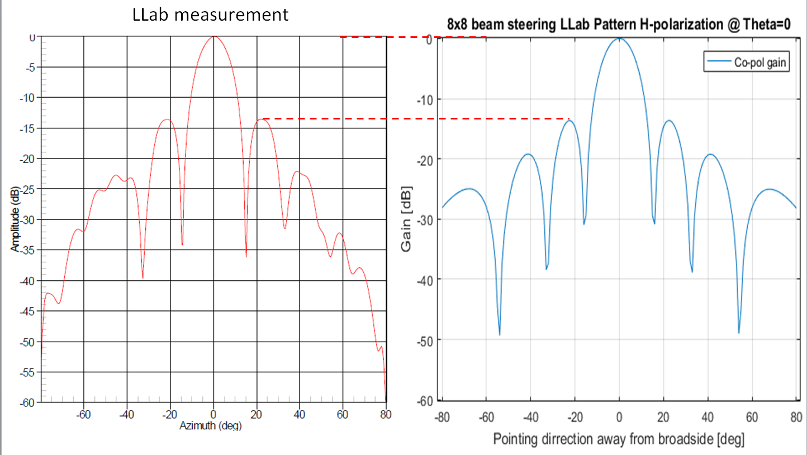
Fig. 9. The TPD panel H-pol copolar patterns: measured (red) simulated (blue).
Visual comparison of the copolar patterns indicates agreements in the width of the main lobe. Further, the nearest side-lobes are at the same level and beamwidths are equal. The slight difference in the side-lobes that are 40º away from broadside is likely due to the measurements setup and antenna support structure (masking of maxima and ripples). As the measurement data is not available, a more detailed comparison than the visual is not possible.

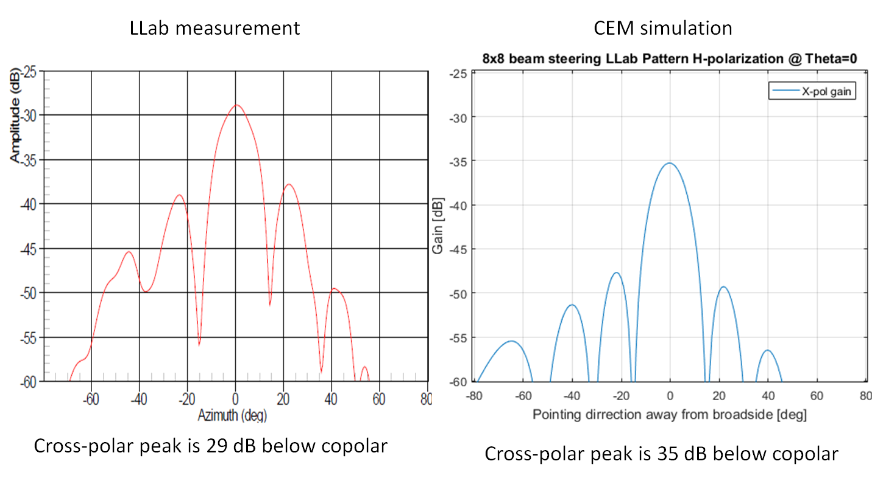
Fig. 10. The TPD panel H-pol cross-polar patterns: measured (red) simulated (blue).
Contrary to the good agreement in copolar patterns, cross-polar patterns exhibit about 6 dB offset, whereas the shape and number of extrema remain the same. With the cross-polar radiation levels approximately 30 dB below the main-lobe and possible measurements issues we consider this result acceptable.
The 8 by 8 model with all elements excited is therefore considered reliable. Of specific interests to us are the differential relations between H and V polarizations. Namely, the differential gain required to calibrate the measured${ Z}_{DR}$, and the differential phase, that causes offset in the measured$Φ_{DP}$. These two variables are calculated as:
$G_{diff}=\frac{{\left|F_{hh}\right|}^{2}}{{\left|F_{vv}\right|}^{2}};$ (1)
$ϕ_{diff}=\arg\left(F_{vv}\right)-\arg\left(F_{hh}\right).$ (2)
These differential variables can bias the polarimetric measurements and are intrinsic characteristics of the antenna. Both of the variables depend on the pointing direction and thus should be evaluated at all pointing angles. This, for the H principal plane, is shown in Fig. 11, where the differential gain and the differential phase are drawn as functions of the beam steering angle and evaluated at the center of the main beam.
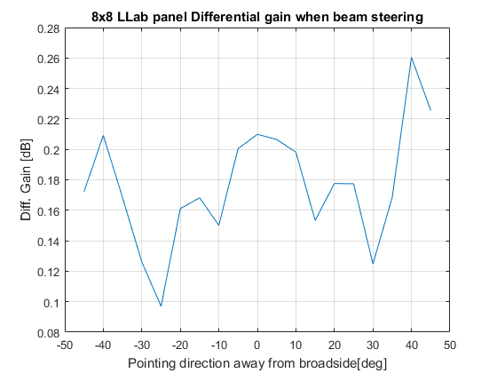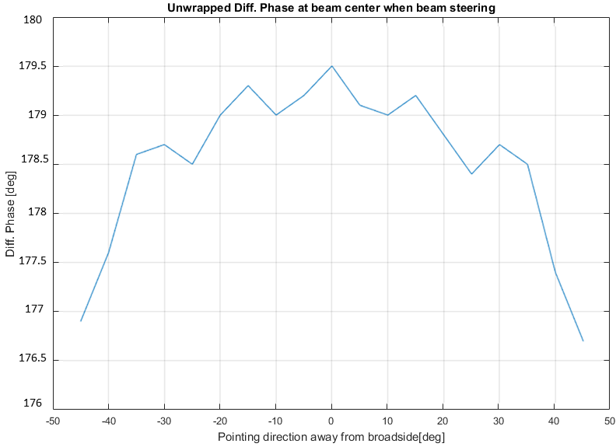
Fig. 11. The differential gain and differential phase of the single TPD panel evaluated at the beam center in the principal H plane
The plot in Fig. 11 (left panel) shows that the maximum difference in the differential gains due to the antenna itself is approximately 0.16 dB and the maximum differential phase (right panel) is about 3º one-way. However, it is important to note that these values are for the antenna proper, as the radome and other structures may affect and change these results. Following is the evaluation of the radome influence on these two parameters.
3.3.1 The 8x8 TPD panel model with radome cover
The TPD radar has a multilayer radome covering the antenna. The radome influences the EM fields generated by the antenna and may cause significant differences in polarimetric properties of the antenna radiation. The wet radome is expected to produce the most significant changes to polarimetric biases, as water on it may affect the radiation for each polarization differently. Furthermore, the TPD’s radome support has a surrounding metal structure in the form of a 3 mm “deep” tub Fig.12. This “tub” may accumulate rainwater while the antenna is zenith pointed (bird-bath mode). This is especially troublesome as the TPD is being tested in bird-bath configuration.
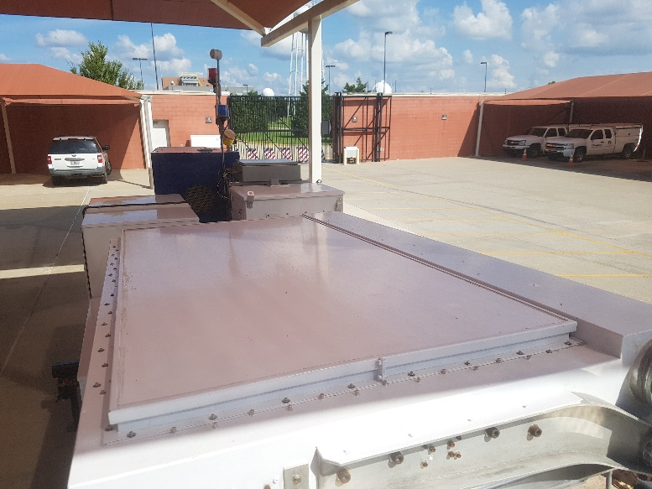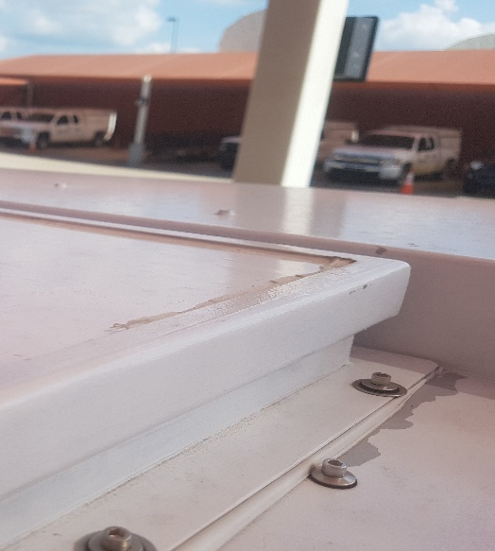
Fig. 12. The TPD radar antenna (left) and the radome support with the “tub” (right) where water accumulates.
The radome influence on the differential variables is demonstrated by modeling radome structure over the antenna panel without the supporting metal structure. The model consists of a single antenna panel and a 25.4 mm thick 3-layer radome. Additionally, a 3 mm uniform water layer is added on top of the three radome layers. Note that such high water level can exist because of the “tub” atop the radome. In weather surveillance, the radome would most likely be dry or if raining water would not accumulate but create streamers. Hence calibration for such case should be investigated. Nevertheless, as the TPD has been mainly operated in the bird-bath mode these simulations are needed to fully understand these measurements.

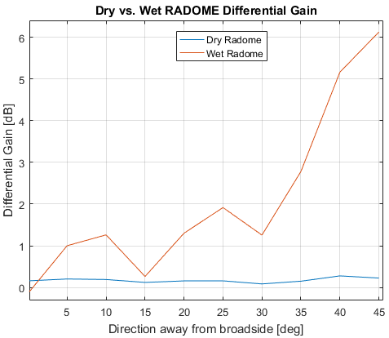
Fig. 13. The differential gain at the beam center of the single TPD panel model with the “dry” radome structure (blue) and water covered radome (red).
Comparison of radiation properties of the “dry” and “wet” radome atop the TPD panel is illustrated by the differential gain and differential phase at the beam center as a function of the steering angle. Comparing the differential values of these variables provides immediate insight into the bias caused by the water collected in the radome “tub” atop the TPD radar antenna.
The differential gain of the dry radome is within the range of values observed on the antenna alone (without radome), while the water covered radome shows the significant differential gain increase across the scanning angle.
The increase of the differential gain is expected due to the different nature of EM wave reflection off of the radome. Namely, as the beam is steered in the H cardinal plane the H polarization has oblique incidence to the radome. At the same time, V polarization has parallel incidence to the radome at all beam steering angles. This results in a different decrease of the antenna gain through the radome for different polarizations, causing the change in the differential gain.
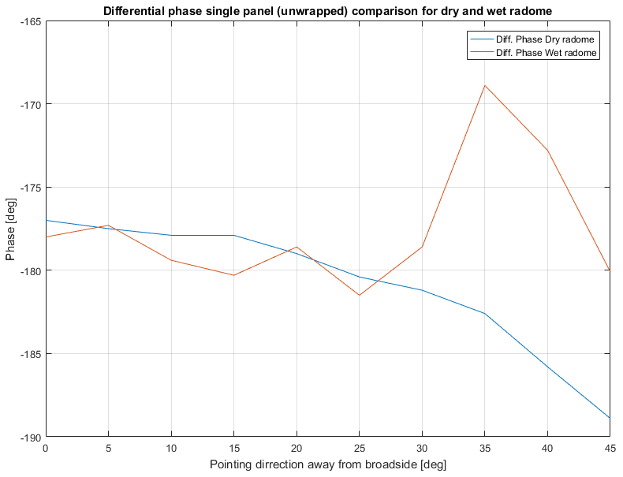
Fig. 14. Single panel one-way differential phase at beam center as a function of beam pointing direction for dry (blue) and water covered (red) radome. The radome is modeled as a three-layer structure with an additional 3 mm thick water layer.
The one-way differential phase in Fig. 14 reveals the influence of radome and water film on top of it. We can identify radome as the cause of differential phase swing due to about 15º differential phase swing at 45º away from broadside. The water layer on top of the radome seems to increase the differential phase further up to 20º away from broadside. For beam steering angles larger than 35º the differential phase increases abruptly to more than 15º at the 35º pointing direction. This deviation of the “wet” radome differential phase is not expected on a real antenna because its radome and supports would be enclosed.
Graphs in Fig.14 yield another fact: To properly dealias (unwrap) the differential phase its initial value should be determined at each pointing direction. This is to account for the noticeable difference in the differential phase between the broadside and 45º pointing direction in the dry radome case.
The differential phase for the antenna without radome is caused by the slight shift of the antenna’s phase center. This phase center shift is computed from the copolar phase at the beam-peak at every beam steering position. Fig. 15 presents the copolar phase of the antenna with and without radome, and for two different positions of the reference element. The reference element is the element of zero phase offset when beam steering. In Fig. 15 the reference element is either on the upper left corner (edge) of the array or in the center of the array (center) looking at the front side.
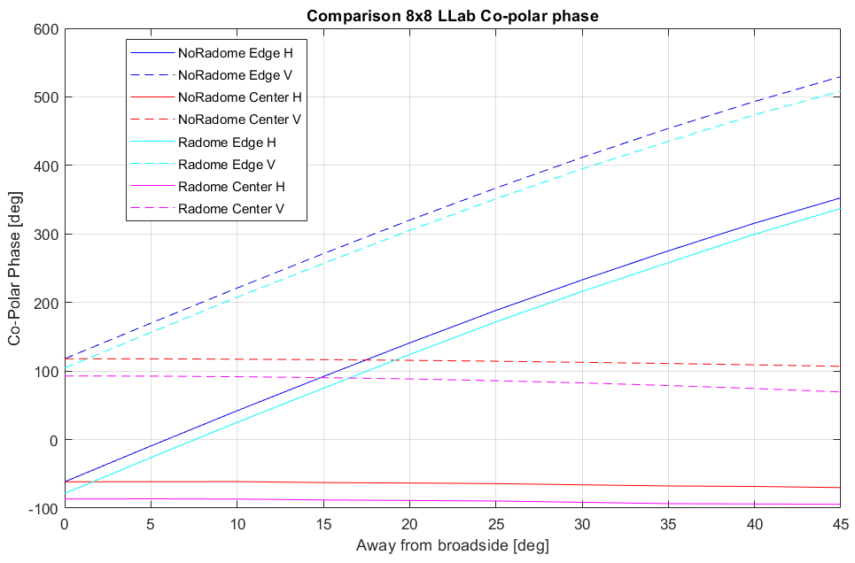
Direction away from broadside [deg]
Copolar Phase [deg]
Fig.15. One-way copolar phases at beam center as a function of beam pointing direction for two reference element configurations and polarizations. Copolar phases for the horizontal polarization are plotted in solid, whereas the vertical polarization phases are drawn as dashed lines.
The monotonic increase of the copolar radiation phase is associated with the position of the array’s reference element. If the reference element is set at the edge or corner of the array the copolar radiation pattern phase at beam center experiences monotonic increase with pointing direction. If the reference element is in the center of an array the copolar phase at beam-center experiences minor phase change which in case of differential phase results in the same differential phase swing as in Fig. 11 (right) and Fig. 14 (dry radome case).
Examining the copolar phase it is obvious that the array’s phase center position is the main cause of the observed differential phase for the antenna without radome (Fig. 11 right). Once the radome is put atop the antenna its capacitive coupling is stronger to the polarization parallel to beam steering plane causing larger phase center shift.
4. Modeling of the Ten Panel Demonstrator
Modeling of the complete Ten Panel Demonstrator Radar antenna is a very challenging task. The physical multilayer structure and size of the antenna make this model complex. A large number of dielectric building elements influences the numerical/computational intensity of simulation. This is because each dielectric plate requires four unknowns (currents) compared to only two for the perfect electric conductor (PEC) plate. Therefore, in model development, we try to simplify the structure, without changing its radiation properties. Simplifying the structure decreases simulation time, yet the decrease is not linear and depends on the specific computer architecture.
4.1 Modeling using exact techniques
Model simplification was considered in various ways for the TPD antenna. The most significant is the array’s symmetric topology. Use of symmetries in CEM is a very common option, yet non-symmetric excitations make this problem slightly more complex than a complete symmetry (topology and excitation). In the simulation, the symmetry is applied by setting a perfect magnetic conductor (PMC) in the plane of symmetry. The image theory dictates that the structure and excitations are symmetrically replicated in half-space behind the PMC. Contrarily, the anti-symmetry is substituted by the PEC. These two cases assume that structure and excitations are replicated in the same manner. Cases in which topology and excitations are not symmetric or anti-symmetric is specifically important for PAR. Their topological symmetry is used while excitations are set independently to electronically steer the beam. Symmetric topologies with non-symmetric excitations can be simulated in the multi-step process. Each of the (a)symmetry planes are separated in two sets, in one the (a)symmetry plane is substituted by a PEC, and in the other by the PMC. In case of multiple (a)symmetry planes, PEC/PMC combinations are simulated for each. The results obtained in these simulations are then combined to obtain a final solution with the desired excitation.
The WIPL-D software uses a method of moments and surface integral equations to simulate large EM structures. Simulation of TPD is based upon the use of (a)symmetry of the TPD’s antenna. The Fig. 16 shows the TPD radar (Fig. 16a), modeled full antenna array (Fig. 16b), single panel of the TPD (Fig. 16c) and single element of the array with differential feeding probes for horizontal (H) and vertical (V) polarization (Fig. 16d). The array simulated is, in fact, a quarter of the complete topological structure, while excitations are defined for all array elements. This results in simulations having about 300k unknowns compared to more than 1.2 million unknowns which would ensue if the whole antenna were simulated. This approach reduces the solution matrix size to about 670 GB (for 300k unknowns) from 10.47 TB (for 1.2 million unknowns). This directly affects our capability to simulate the antenna because the problem with 1.2 million unknowns cannot be simulated with our computing capabilities. Yet the 300k model takes about 48 hours to solve on the multi graphics processor unit (GPU) card personal computer (WIPL-D, 2019).
Establishing the exact mismatch between H and V copolar beams is one of the important tasks for CEM. Yet, the shape, position, and isolation between the copolar and cross-polar radiation patterns of the antenna (without backend coupling) can only be evaluated using a CEM model. Therefore, here we examine the copolar and cross-polar lobes when beam steering in principal and out of the principal plane.
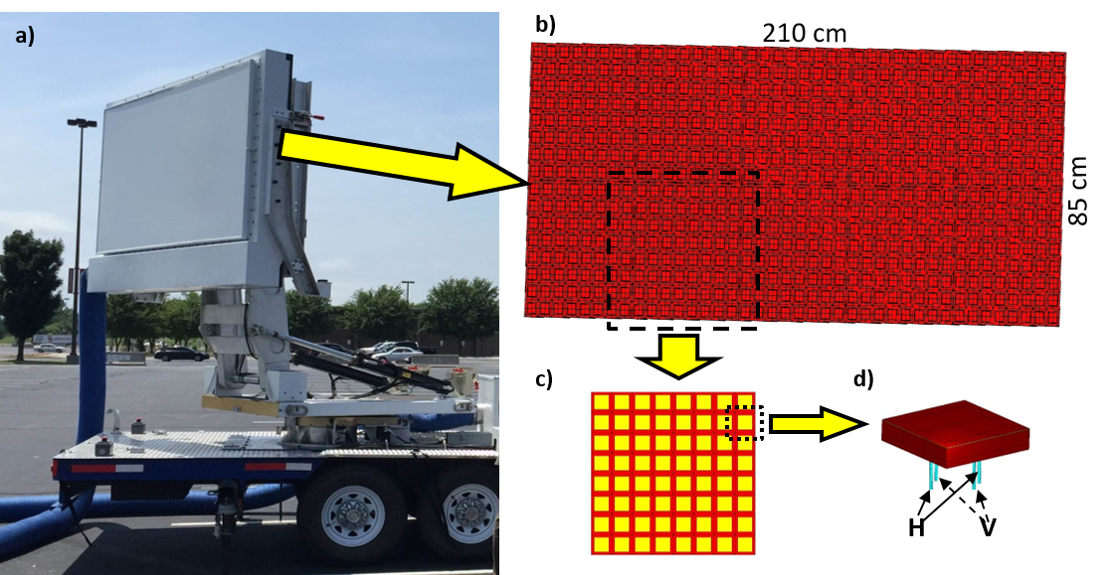
Fig. 16. a) The Ten Panel Demonstrator radar; b) the antenna model; c) antenna panel; d) the antenna element with four differentially fed probes.
In the antenna model (Fig. 16b) excitation of each element in the array can be individually set. This is done by adjusting the phases on four element ports (Fig. 16d) of each element. Therefore, all pointing direction can be simulated. The results we obtain are copolar and cross-polar radiation patterns in the Ludwig 2 definition (L2), (Ludwig 1973). The L2 is preferred for use in weather radar (Fulton 2018). The broadside copolar and cross-polar radiation patterns are presented in Fig. 17.
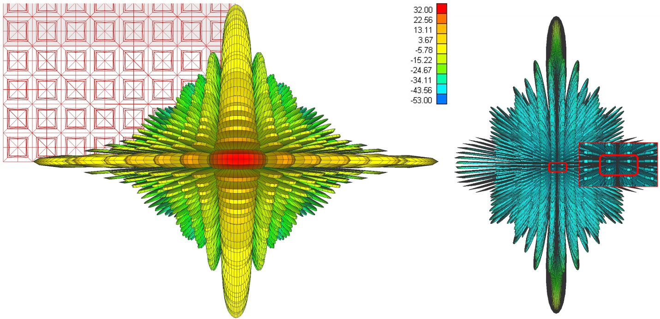
Fig. 17. Antenna patterns of the ten-panel demonstrator, (left) copolar f_{hh}(θ, ϕ), (right) cross-polar f_{vh}(θ, ϕ) and its enlarged values within the main beam (encompassed with the rectangle). The beam is pointing broadside. The peak to peak isolation within the main lobe is over 50 dB while the cross-polar minimum is aligned with the copolar peak. The color bar indicates values in dBi.
The broadside pattern exhibits expected behavior with symmetric side-lobes. The beamwidths are: in horizontal (azimuth) direction 6.7º in elevations it is 2.6º. The most significant for weather radar application are properties of the cross-polar radiation pattern within the main lobe. The cross-polar pattern within the main copolar beam in Fig. 17 has four symmetrically placed cross-polar lobes around the origin. This is beneficial as the contribution to the signal from these lobes, due to their opposite phases, cancel out the first order bias term in the polarimetric variables (Zrnic et al. 2010). Isolation between the copolar maximum and cross-polar maximum is over 50 dB in transmission. The beam center to cross-polar center isolation is significantly larger and would be overwhelmed by the channel cross-coupling in the backend.
If the copolar beam is steered away from the broadside in the horizontal principal plane, the cross-polar lobe formation changes from four opposite phase lobes (Fig. 17) to only two. These two lobes have opposite phase as well. This feature also cancels the first order bias term in the polarimetric variables. A specific example in Fig. 18 of patterns for a pointing direction in the horizontal principal plane but 35º away from broadside illustrates the effect.
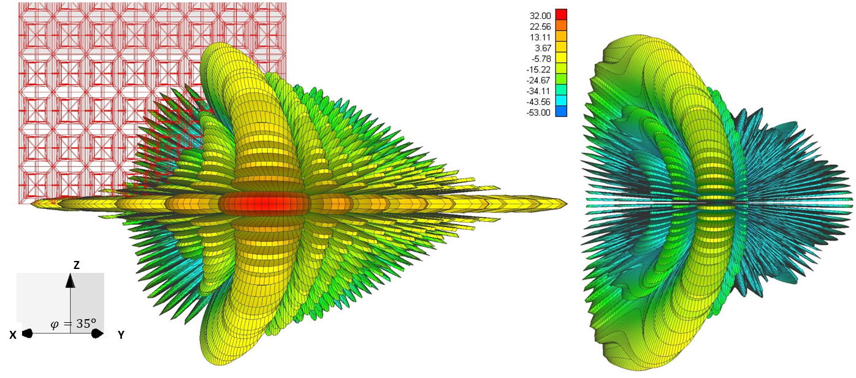
Fig. 18. As in Fig. 17 except the beam is pointing at 35º in azimuth and 0º in elevation. The peak to peak isolation is about >40 dB and the cross-polar radiation has a minimum aligned with the copolar peak. The color bar indicates values in dBi.
Finally, if the beam is steered away from the principal planes (e.g., ϕ = 28º, θ = 14º), (Fig. 19) the cross-polar lobe formation changes significantly. The copolar beam axis is at azimuth=28.5º and elevation=12.25º. Clearly, it is offset from the commanded directions. This may not be very significant considering that the beamwidths are relatively large, still, it should be accounted for. The cross-polar peak is within the main beam of the copolar pattern but is positively offset from its center in azimuth by 1º and negatively offset in elevation by 0.5º. It is about 24 dB below the copolar main lobe and is caused by the geometrical coupling and “non-radiating” sides of patches. Low isolation will cause bias in the case of SHV polarimetric mode. If the phase coding is used in SHV mode (to suppress bias first order couplings) the 24 dB isolation might be sufficient. Nevertheless, this is not the total isolation between the channels as the backend may introduce additional coupling.

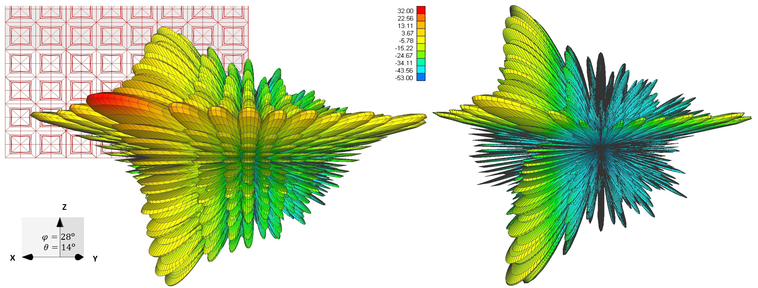
Fig. 19. As in Fig. 18 but the beam is pointing at 28º in azimuth and 14º in elevation. The peak to peak isolation is about 24 dB and the cross-polar peak is within the main beam of the copolar pattern. The color bar indicates values in dBi.
For the calculated radiation patterns, we can evaluate antenna induced polarimetric biases as a function of angle. The cause of these biases is in the non-radiating sides of each patch element (cross-polar bias) and the geometrical projection of fields (geometrical bias). To determine the causes of the observed differential phase and Z_{DR} bias (Mirkovic 2018) we calculated the differential phase and differential gain that were observed by TPD in light rain (zenith pointing). The differential gain biases the Z_{DR} and the system differential phase introduces an offset to the measured differential phase. These biases are intrinsic to the system (antenna and backend together). Depending on the intended polarization, the calculated fields determine the copolar or cross-polar radiation pattern of the antenna. For each of the beam direction, we obtain horizontal and vertical component of the field. The phases of these components can be arbitrary resulting in elliptical polarization for either of the ports excited. For this general case knowing the components and their phase difference we can calculate the tilt of the polarization ellipse $ζ$ in case of the vertically oriented panel as:
$ζ=\frac{1}{2}\arctan\left(\frac{2F_{hv}F_{vv}}{F_{vv}^{2}+F_{hv}^{2}}\cos\left[∢\left(F_{vv}\right)-∢\left(F_{hv}\right)\right]\right)$, (3a)
where $ζ, F_{hv}, F_{vv}$ depend on the pointing direction (θ₀, ϕ₀) and $F_{hv}, F_{vv}$ are the voltage (one way) maxima of the radiation patterns for vertical polarization. Similarly, the polarization ellipse tilt $ξ$ for horizontal polarization is:
$ξ=\frac{1}{2}\arctan\left(\frac{2F_{vh}F_{hh}}{F_{hh}^{2}+F_{vh}^{2}}\cos\left[∢\left(F_{hh}\right)-∢\left(F_{vh}\right)\right]\right)$. (3b)
The F_{ij}s are values of (B6) at beam center.
The differential gain is
G_{dif} = g_{h}(dB) – g_{v}(dB). (4)
The antenna creates a differential phase between the horizontally and vertically oriented fields, as given by (5). Angular dependences of the differential phase and gain of the TPD as a function of beam pointing direction in the horizontal principal plane are plotted in Fig. 20. The values in Fig. 20 are calculated for the antenna without radome cover (blue) and with radome cover (red). The differential phase (Fig. 20 left) for the TPD antenna with the radome cover exhibits significant change. The dependence is similar to the one observed at zenith pointing measurements (Mirkovic and Zrnic 2018b). One should note that the phases in Fig. 20 are one-way, while the total differential phase affecting radar measurements is the two-way (transmit and receive) value. In general, transmission and reception antenna effects are not identical (i.e., there can be taper on reception) thus should be calculated separately.
$Φ_{Tx}=\arg\left(F_{vv}\right)-arg⁡(F_{hh})$ (5)
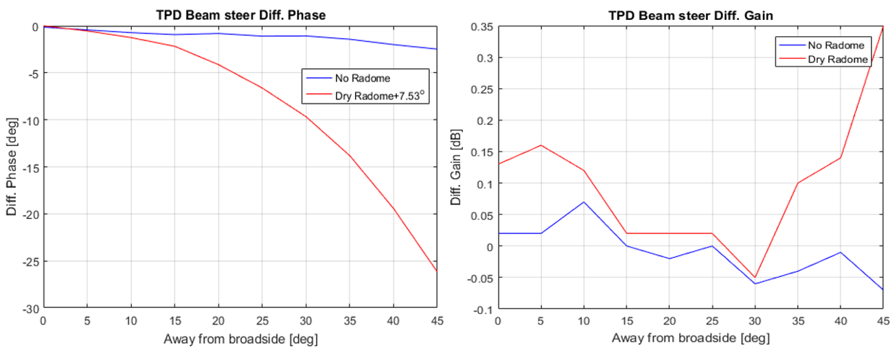
Fig. 20. Differential phase and differential gain calculated at the beam peak of the TPD antenna as a function of beam position. Curves in blue represent the values for the antenna without radome whereas the red curves represent values for the radome covered antenna.
Differential phase variation of the TPD antenna is on the order of 2 to 3º and is due to the change in the phase center position while beam steering. With the radome, the differential phase increases to about 26º. This significant difference is caused by the reflection mechanism that is not the same for the two polarizations. While the vertically (V) polarized fields have parallel incidence to the radome, the horizontally (H) polarized fields have oblique incidence as the beam is steered in the horizontal plane.

4.2 Modeling using approximate techniques
Approximate techniques can be applied to compute the patterns of the TPD antenna array. Here we consider the application of the infinite array approximation using the HFSS software. The simulation was carried out by our collaborators at GTRI with results provided in a report (Lazar and Skala, 2015). Results provided are the simulation of broadside copolar and cross-polar pattern (Fig. 21).
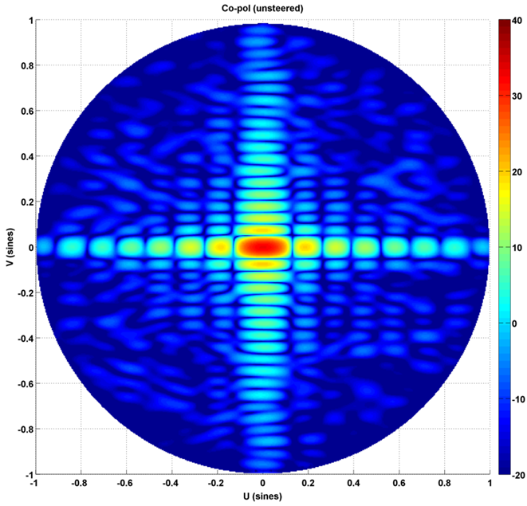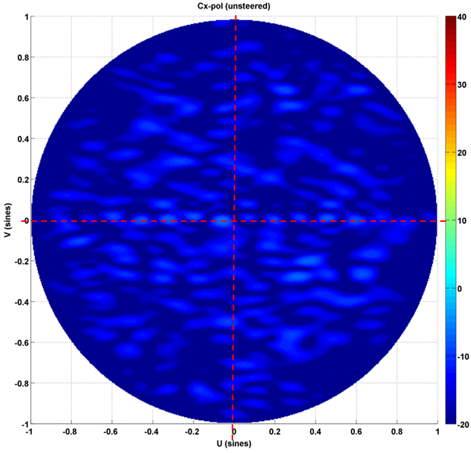
Fig 21 – Ten Panel Demonstrator copolar (left) and cross-polar (right) radiation pattern at broadside calculated using the infinite array method in HFFS software. The color bar is dBi and the red dotted lines are added to the cross-polar pattern to facilitated reading.
Comparing the results in Fig. 21 with WIPL-D broadside results in Fig. 17 we see that the copolar main lobe and sidelobes on principal planes are well approximated. However, out of the principal plane copolar far sidelobes in Fig. 21 (left) are not symmetric as in Fig. 17 (left). A more significant deficiency of the approximate technique is evident in the cross-polar pattern. The symmetry of the cross-polar pattern is absent in the results in Fig. 21 (right). Furthermore, the results do not predict four symmetrical cross-polar lobes. As aforementioned, this is especially important as the phases of adjacent lobes differ by 180º. This cancels the first order bias terms in the polarimetric variables which would otherwise be produced by the cross-polar voltage patterns.
Overall approximate techniques may be sufficient for determining the beamwidth and shape of the copolar pattern. However, application for determining features of far sidelobes and cross-polar radiation is limited and may not satisfy the necessary requirements for use in polarimetric calibration.

Appendix A: Decrease of correlation coefficient ρ_{hv} due to beam effects
Herein we present a simple formula for the decrease in correlation coefficient due to differences in beamwidth and differences in pointing direction. Assume that the two-way widths (sigma) of the Gaussian patterns at the H and V polarizations are σ_{h} and σ_{v} and that the difference in pointing direction is Δ. Assume that the beams are very narrow so that the overlapping and significant parts of the beam cross-section can be assumed to be flat. Furthermore, the resolution volumes are filled with spherical scatterers so that in case of perfectly matched beams in width and pointing direction the correlation is (A1). In Figure A1 plotted are the cross sections of the two overlapping beams.

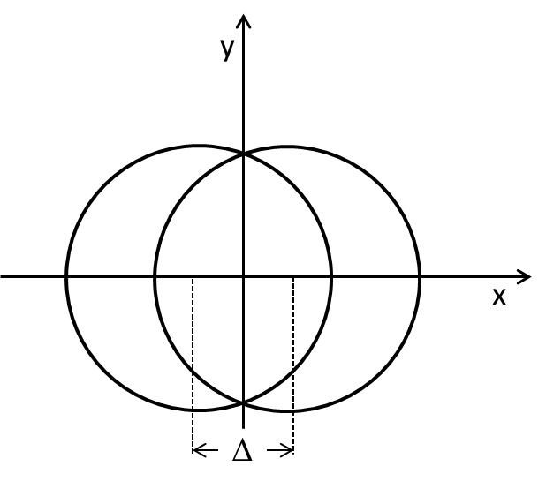
Fig. A1. Cross section of two overlapping beams whose centers are offset by Δ.

Let the two-way pattern be
, (A1)
where it is assumed that the beam center is at x=0, y=0. The choice of Cartesian coordinates, as opposed to polar ones, is convenient because it makes integrations simple. The correlation coefficient is computed from the formula

. (A2)
In (A2) the subscripts h,v distinguish the patterns of horizontal and vertical polarizations. Now for the assumed geometry (Fig. A1) and assuming that the pattern for H polarization is offset by – Δ/2 and from V polarization by Δ/2 from 0 the equations for one way patterns are

(A3a)
and:
. (A3b)

In terms of the one way 3 dB beamwidths θ_{1h}, θ_{1v}: The integrals in (A2) are two dimensional over x and y and for the case of interest (narrow beams) can be extended from –∞ to ∞. With this extension, closed-form solutions are straight forward. Performing these operations one obtains the formula

. (A4)

A quick check indicates that for zero offset and the same beam widths the correlation is 1.
In deriving (A4) it is implicit that the antenna beams are circular. For elliptical beams the pertinent equation (A3a) becomes

(A5a)
and an analogous equation for the V pattern is

(A5b)

In these equations, the σ_{hx} and σ_{hy} are the H pattern widths in the direction x and y respectively, and Δ₁, Δ₂ are the offsets in the x and y directions. The σ_{vx} and σ_{vy} are the widths of the V pattern in the x and y directions. With this extension the correlation coefficient becomes

. (A6)

In our specification for MPAR, we have assumed spherical beam cross section and have separately given the conditions

or similar. In reality, it is (4) or (6) that should be larger than 0.99 (perhaps 0.995?). One can see then that in case of circular beams the condition would depend on two parameters σ_{h}/σ_{v} and Δ/σ_{v}. For elliptic beams the following four parameters σ_{hx}/σ_{vx}, Δ₁/σ_{vx}, σ_{vy} /σ_{vy}, and Δ₂/σ_{hy}.

Next, for simplicity and illustration assume that beams pointing directions are matched so Δ=0 in (A4) but there is a mismatch of beam widths as follows.
σ_{v} = (1±ε)σ_{h}, (A7)

where ε is a number much smaller than 1. Insertion of these two conditions in (4) and assuming that the mismatch causes a reduction in the correlation r=ρ_{hv}(not matched)/ ρ_{hv}(matched) one obtains the following relation

. (A8)

Explanation: Assume that the matched correlation ρ_{hv}(matched) = 1 and that we allow at most a drop due to mismatch to reduce it means that we are solving for the largest ε for which this inequality will hold. It is easy to solve the equality in (A8) which is
. (A9)
Say we allow a drop in correlation to 0.997, thus r = 0.997 and (rounded) ε₁ = 0.08, ε₂ = -0.08. Then if the 3 dB beamwidth (h polarization) θ_{1h}=1º the θ_{1v} could be between (rounded) 0.92 and 1.08º. This can be also cast as difference at the 20 dB level from the peak of the pattern.

Note that the angle with respect to beam center at the L (dB) level below the peak is

. (A10)
At mismatched beam (A7) holds and we can compute the difference δ₂₀ (dB) between matched and not matched patterns at level L as
. (A11)

Thus if 1+ ε = 1.08 and L=20 dB, the δ₂₀=2.85 dB. If r = 0.999 the δ₂₀=1.7 dB so it is fair to state that at the 20 dB level the difference in the patterns should be less than 2 dB, provided that at the peak the gains have been matched.

Appendix B:
Bias in rain rate estimates due to cross-coupling in the SHV polarimetric mode
(Dusan S. Zrnic)
B1) Introduction
This appendix examines the bias in rainfall estimates due to the coupling between the signals in the horizontal (H) and vertical (V) channels in case of simultaneous H and V (SHV) transmission and reception mode. The rain rate relation is an R(A) function where A is a specific attenuation that is obtained using the differential phase Φ_{DP}. This will be explained shortly.
The bias in differential reflectivity Z_{DR} of 0.1 dB (for Z_{DR} between 0 and 1 dB) is quoted as the driving requirement for setting the cross polarization isolation (Zrnic et al. 2010). And it has a quantitative foundation on the requirement that the fractional bias in rain rate (ΔR/R) from an R(Z, Z_{DR}) relation does not exceed 0.1. If the cross-coupling component is in phase with the copular component the isolation would need to be over 50 dB to guaranty that in the worst possible case the bias in Z_{DR} will be lower than 0.1 dB (Zrnic et al. 2010, eq. 16b). Analysis of the bias in the copolar correlation coefficient (ρ_{hv}) indicates that its bias is also strongly affected by the cross-polar coupling. The values are plotted in (Michele and Zrnic 2011).
B2) The relation between rain rate and attenuation
The following relation between rain rate and attenuation at 10 cm wavelength has been proposed (Ryzhkov et al. 2014) for estimating rain rate
R(A) = c₁(t)c₂(λ)A^{1.03} , (mm h⁻¹) (B1)
where A is specific attenuation (dB km⁻¹) at horizontal polarization.
If attenuation is obtained from the ZPHI algorithm (Ryzhkov et al. 2014) the relation has the following attractive attributes. It is almost independent of DSD variations, it is independent of absolute radar calibration, it overcomes the effects of partial beam blockage, and it is a measurement at each range gate and thus compatible with the resolution of the Z field.
To grasp how the differential phase Φ_{DP} enters the computations of rain rate I first list the equation for estimating attenuation
, (B2)
where Z_{a} is attenuated reflectivity, ,
(B3)
The assumption is that the attenuation is related to reflectivity by A = aZ^{b} and that it is also related to specific differential phase by A = α₀ K_{DP}. The measurement is constrained between the beginning range r₁ and ending range r₂ such that there is a significant accumulation of differential phase between the two ranges (at least about 2º). It is evident in (B2) that A is directly proportional to and therefore depends on the product bα₀ (see Ryzhkov et al. 2014) but is independent of a. Hence errors in accumulated differential phase map into errors in A and through (B1) into errors in rain rate. The value of the exponent on Z_{a}, b = 0.72 and the maximum α₀ = 0.03 occurs in tropical rain. With these parameters the multiplying coefficient
(B4)
B3) Coupling effect on differential phase
Start with the equation for incremental voltages (as in Zrnic et al. 2010)
(B5)
It should be noticed that the differential phase on transmission β is separated from the differential phase Φ_{DP} as in Zrnic et al. (2010), whereas in the data these are automatically summed up.
Evaluating (B5) and integrating over the solid angle the voltages become
The expected value <> is sought as its argument is the estimated differential phase. Assuming uniform polarimetric variables within the main beam and retaining the zero order and first order terms in F_{hv} and F_{vh} the expected value becomes
The first term in this equation is the bias-free term from which the differential phase can be computed. Note that Φ_{DP} – β is the “total differential phase” that includes transmission part, propagation path, backscattering, and receiver path. What matters is the cumulative bias in (B3) due to coupling. Some thought reveals that the bias can vary between max positive and maximum negative, thus we can assume that the maximum would be if accumulation is 90º.
Furthermore, to simplify the estimation of the worst case bias set Z_{dr} = 1, and ρ_{hv}=1. Examination of (B7) indicates that if the first term is in quadrature with the rest of the terms the angle deviation (bias) from the desired value (i.e., Φ_{DP} – β) would be largest. Now some more approximations are in order. Take F_{hh}=F_{vv} and let the two cross terms be equal and real. Then the bias becomes:
. (B8)
This simple equation has the same term (ratio of integrated pattern function as the one that produces bias in differential reflectivity (i.e., eq 14 in Zrnic et al. 2010) as well as the term that causes the bias and ρ_{hv} (eq. 24 in Galletti and Zrnic 2011).
B4) Evaluation of the bias
As stated, if the accumulation of differential phase equals 90º the worst case bias could occur. So let’s take a fractional bias in rain rate to be p=R/(R-ΔR). That is, assume that the ∆Φ_{DP} has reached 90º because of the maximum bias whereas without bias it would have been (90º – x), where x is the allowed maxim value given by (8). Thus from (B4) evaluate
Clearly
(B9)
and solving for x we find
(B10)
Now assume further that the F_{hv} has the same shape as F_{hh} but differs in gain. Then we can find the permissible ratio of gains (g_{hv}/g_{hh}), where these refer to power gains. We thus find the required difference in gains (dB scale) as
G_{hv} – G_{hh} ≤ 20log[tan(x)] – 20 log(4). (B11)

As a numerical example take p = 1.05 (a maximum bias of 5 % in rain rate). Then substitution in (B10) produces x=3.37º. With this value the required cross polar isolation (B11) becomes -36.6 dB; this is routinely achieved on good parabolic dish antennas.
Next let’s review the bias in ρ_{hv} given by (Galletti and Zrnic 2011, eqs. 21 and 23):
(B12a)
which relates the two gains (in dB) by
. (B12b)

In specifications for the WSR-88D, it is implied that errors in ρ_{hv} should be smaller than about 0.003. Therefore, the quantization interval for this variable is set at 0.00333. Because ρ_{hv} larger than 0.97 is used to indicate mostly one type of hydrometeors like rain or snow it can be considered a representative value for bias computation. Assuming that the bias at ρ_{hv} = 0.97 should be smaller than ½ of quantization interval (i.e., δρ_{hv} ≈0.0015) we find the required gain difference (or isolation) from (B12b) to be -37.9 dB. This will constrain the worst bias in rain rate to less than 5%.
Finally, I list here the equation for bias in Z_{DR} (eq. 16b in Zrnic at al. 2010)
(B13a)
or G_{hv} – G_{hh} ≤ 20log(δZ_{DR}) – 20 log(35). (B13b)

Equation (B13b) indicates that the worst bias in Z_{DR} will be less 0.1 dB if the isolation is better than -50 dB. At isolation of -40 dB the worst case bias is 0.32 dB.
The following conclusions ensue from this analysis. All three polarimetric variables are affected by the cross coupling and a reasonable requirement for the isolation in the worst case should be close to -40 dB. A 0.1 worst case bias in Z_{DR} is likely unachievable and even if achieved would be very hard to verify. A requirement for worst-case bias in ρ_{hv} (about 0.0015) and the worst case bias in Φ_{DP} (about 3.37º) can be met if the cross-polar contribution is 40 dB below the cross-polar contribution. It happens that well designed parabolic dish antennas and associate microwave circuits provide more than 40 dB isolation and therefore in such systems, the significant bias due to coupling has not been observed. However, there are anecdotal evidence whereby badly biased ρ_{hv} has been reported on radars with parabolic dish antennas. Achieving -35 to -40 dB of isolation on polarimetric PAR radars is challenging and might not be economically feasible. Therefore, reduction of bias effects should be sought in the transmitted sequence and processing designs (see for example Zrnic et al. 2014).

APPENDIX C:
Appendix: Numerical solvers for computing patterns of phased array antennas
(Djordje Mirkovic, Hadi Saeidi Manesh)
Measurements and many computations were made at the Advanced Radar Research Center of the University of Oklahoma.
In this appendix, we explore the ability and efficiency of three computational electromagnetic (CEM) solvers for generating copolar and cross-polar patterns of phased array antennas. Of special interest is the feasibility to compute patterns of the Ten Panel Demonstrator (TPD) antenna. Use of the WIPL-D Pro is documented in the main text. Nevertheless, some results are repeated here for comparison with other solvers. The main metric is the deviation of computed patterns from the measured ones. The simulation time is briefly commented at the end.
C.1 Comparison of results
Patterns of a single panel of the TPD in which only four central elements can be excited were measured. Excitation of various polarizations is achieved through active ports. The horizontal (H) and vertical (V) polarizations were measured separately by exciting the corresponding port. All other elements were load matched during the measurement. Measured were E-plane, H-plane and D-plane cuts of the radiation pattern and compared to the results from solvers.

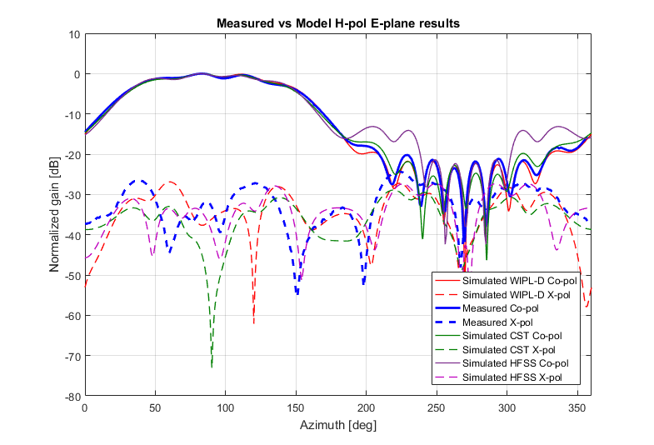
Fig. C1. Measured and simulated patterns in the E-plane of the embedded H-pol element in Fig. 3. Copolar patterns are plotted with solid curves whereas cross-polar (X-pol) patterns are represented with dashed curves.
Fig. C1. shows good accuracy of all solvers. For this particular cut, all solvers provide quite an accurate prediction of the main copolar beam, but the side-lobes exhibit some discrepancy. The HFSS had convergence issues hence in the sidelobe regions it exhibits higher values and misses the details which are captured by measurements. Further discussion on this topic is presented later. The cross-polar pattern is somewhat less accurate in case of the CST solver which predicts an overall lower level compared to the WIPL-D, HFSS and the measured results.
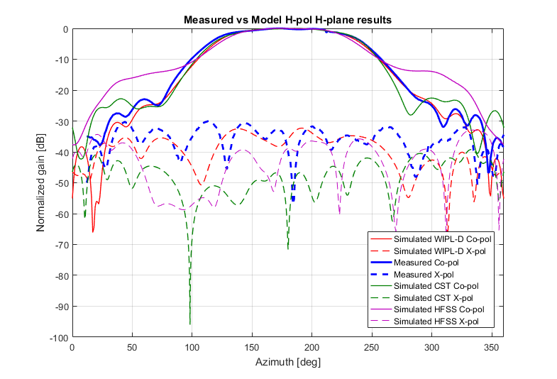
Fig. C2. Measured and simulated patterns in the H-plane of the embedded H-pol element as in Fig. 5. Copolar patterns are plotted with solid curves whereas cross-polar (X-pol) patterns are represented with dashed curves.
The computed main lobes (Fig. C2) appear slightly less accurate than in the E-plane (Fig. C1). Here all simulated results agree quite well with the measurement in the 100º to 250º region although the measured main lobe is slightly wider. CST and WIPL-D main lobe patterns between 50º and 150º match well but the measured main lobe is a bit larger. The pattern computed with HFSS misses the sidelobes, due to convergence problems. On the opposite side of the main lobe (200º to 275º), the pattern computed with CST falls off quicker compared to the measured and WIPL-D patterns. Similarly to the results in Figs. C1 and C2, the CST predicts a slightly higher level of the first sidelobe than the measured and the WIPL-D computed ones. The computed cross-polar patterns by the CST solver are about 15 to 20 dB lower than the measured and WIPL-D patterns, while the pattern computed with the HFSS is in-between the patterns from these two simulators.
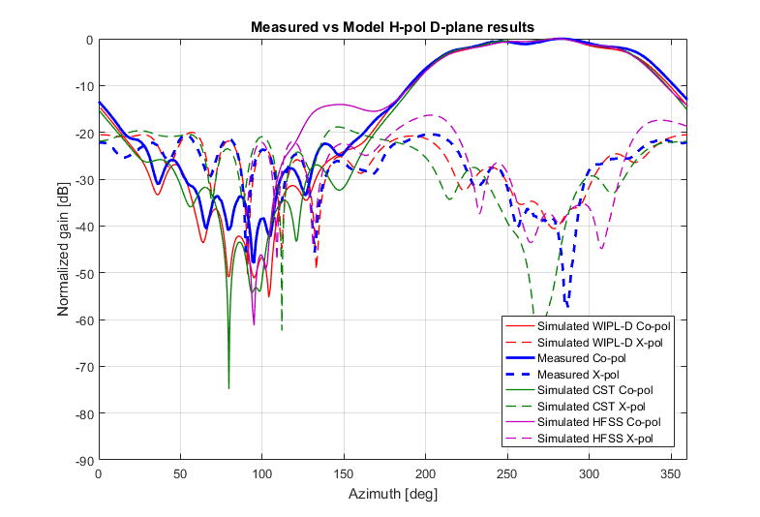
Fig. C3. Measured and simulated patterns in the D-plane of the embedded H-pol element as in Fig. 3. Copolar patterns are plotted with solid curves whereas cross-polar (X-pol) patterns are represented with dashed curves.
In Fig. C.3 are the patterns at horizontal polarization (H-pol) in the D-plane. In the main-lobe region, the computed copolar and cross-polar patterns agree well with the measured one. Within the main lobe, the shape of the sidelobes computed by WIPL-D is in better agreement with measurement than the shapes computed by the other two solvers. This is important because the sidelobes of an antenna populated with the same elements determine the biases in the polarimetric variables. For example, if the sidelobes within the main lobe exhibit four symmetric peaks, the bias in polarimetric variables caused by coupling is significantly reduced (Zrnic et al. 2010, Galletti and Zrnic 2011). Outside of the main lobe, the measured sidelobes agree best with the sidelobes computed with WIPL-D. The ones computed with CST agree almost as well except at angles 0º to 50º. The D-plane has strongest cross-polar radiation and is typically used as a benchmark for cross-pol simulation results.
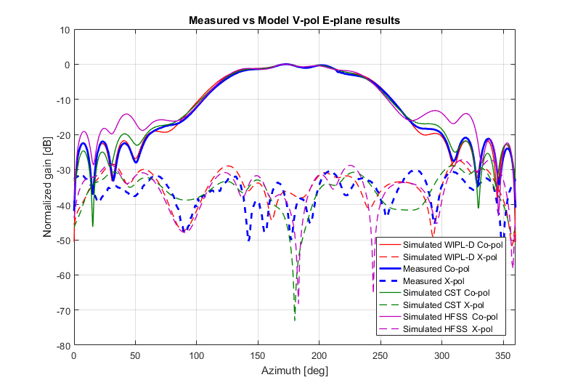
Fig. C4. Measured and simulated patterns in the E-plane of the embedded V-pol element as in Fig. 3. Copolar patterns are plotted with solid curves whereas cross-polar (X-pol) patterns are represented with dashed curves.
Both copolar and cross-polar patterns of the vertically polarized patch (Fig.C4) computed with all three solvers agree very well with the measurement. The exception is that the sidelobes of the copolar pattern computed by HFSS are higher which we attribute to convergence issues in computation. The cross-polar patterns have similar levels and even shape which is considered satisfactory.

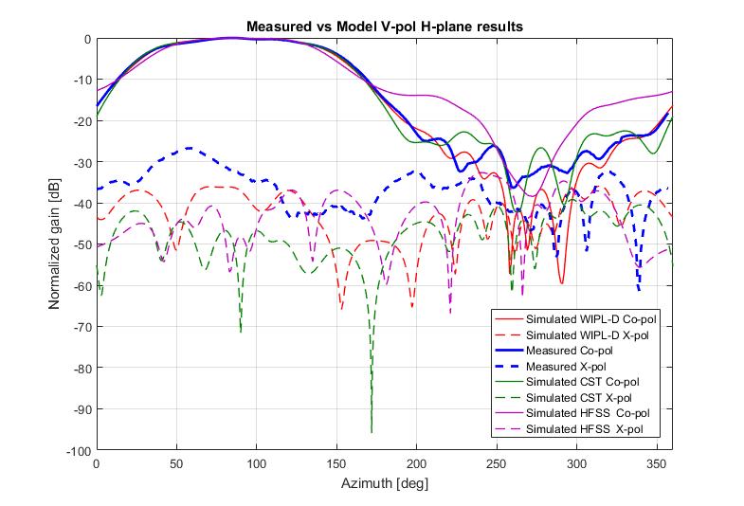
Fig. C5. Measured and simulated patterns in the H-plane of the embedded V-pol element as in Fig. 3. Copolar patterns are plotted with solid curves whereas cross-polar (X-pol) patterns are represented with dashed curves.
The patterns in Fig. C5 and within the main lobe exhibit similar shapes and agreement as in case of the embedded H-pol element (Fig. C2). The cross-polar patterns are quite different from the measurements presented in Fig. C2. It is immediately evident that the measured cross-pol patterns within the main lobe are higher than in Fig. C2. Evidently, all simulators have failed to replicate measurements of this higher cross-pol (40º to 90º). Measured copolar side-lobes (225º to 300º) are higher than those measured in H-pol H-plane, indicating the simulations are not closely matched with the measurements. The overall conclusion is that a probe positioning or similar effect has biased the measurement. This would cause the measurements to be corrupted everywhere but at the main beam as we see in Fig. C5.

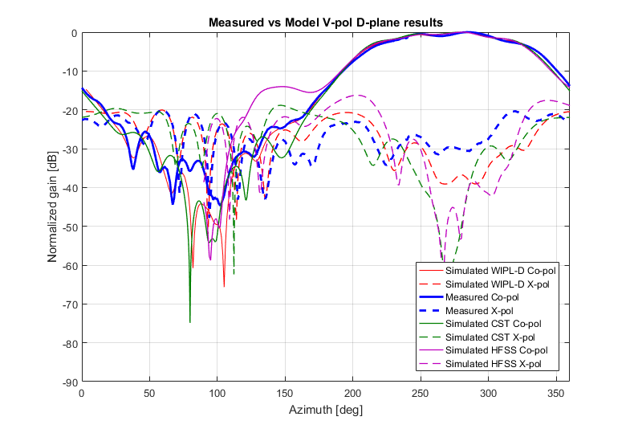
Fig. C6. Measured and simulated patterns in the D-plane of the embedded V-pol element as in Fig. 3. Copolar patterns are plotted with solid curves whereas cross-polar (X-pol) patterns are represented with dashed curves.
The patterns in the D-plane (Fig. C6) of the patch with exited V polarization are very similar to the ones obtained with the H polarization excited (Fig. C3).
C.2 Simulation time and hardware
Simulations using all three solvers were carried out on PCs with similar capabilities. All PCs use Intel i7 processor and 32GB of RAM memory. Simulation time varied due to the simulation setup and solver. All three solvers simulated a single panel model with central elements active and the rest load matched. The results are in Table 1.
Table 1 – Simulation time for single panel with one embedded element excited for both polarizations for each of the solvers.
 | WIPL (MoM) | CST (Transient) | HFSS (FEM)
Time | 3h 20min | 5h 30min | 6h*

Our hardware capabilities were the limiting factor in this case. The HFSS should converge with use of a better computer, yet the time cost of such simulation would be much higher than of two other solvers presented.
The overall conclusion about the computational tools tested is very supportive of the CEM modeling process for polarimetric phased array radar antenna calibration. All three CEM software can accurately simulate the patterns of moderate size phased array antenna. The simulation times are within a factor of two and are the main cost.

References
Galletti, M., and D. S. Zrnic, 2011: Bias in copolar correlation coefficient caused by antenna radiation patterns. IEEE Trans. Geosci. Remote Sens.,49, 2274-2284.
Ryzhkov, A., M. Diederich, P. Zhang, and C. Simmer, 2014: Potential Utilization of Specific Attenuation for Rainfall Estimation, Mitigation of Partial Beam Blockage, and Radar Networking. J. Atmos. Oceanic Technol., 31, 599-619.

Zrnic, D.S., R.J. Doviak, G. Zhang, and R.V. Ryzhkov, 2010: Bias in differential reflectivity due to cross-coupling through the radiation patterns of polarimetric weather radars. J. Atmos. Oceanic Technol., 27, 1624-1637.
Zrnic, D.S., R.J. Doviak, V.M. Melnikov, and I.R. Ivic, 2014: Signal design to suppress coupling in the polarimetric phased array radar. J. Atmos. Oceanic Technol.,32, 1063-1077.

Zrnic D.S., D. Mirkovic, 2018a: Sensitivity of Calibration Parameters for Polarimetric Phased Array Weather Radar. AMS 98th annual meeting, Austin, TX, Amet. Met. Soc https://ams.confex.com/ams/98Annual/webprogram/Paper336825.html
Mirkovic, D., and D. S. Zrnic, 2018b: Polarimetric calibration using the computational electromagnetic approach. 2018 IEEE Radar Conference (RadarConf18), 1348-1352. Oklahoma City. doi:10.1109/RADAR.2018.8378760
MIT Lincoln Laboratory, 2012: Multifunction Phased Array Radar (MPAR) Government Proof of Concept Demonstrator -Final Test Report Gen.1 Panel Evaluation. Boston: MIT.
WIPL-D, 2019: WIPL-D Pro EM solver. (WIPL-D d.o.o) Retrieved 2 28, 2019, from www.wipl-d.com
Zrnic, D. S., V. M. Melnikov, and J. K. Carter, 2006: Calibrating differential reflectivity on the WSR-88D. Journal of Atmospheric and Oceanic Technology, 23(7), 944-951.
Lazar, D and J. Skala: MPAR-MIT/LL Realistic-Element Modeling, Georgia Tech Research Institute, report presentation, 02/10/2015.

Symmetric topology with non-symmetric excitations in WIPL-D software is addressed as (A)symmetric.
HFSS had only partial convergence ($Δ_{S}=0.027$) in the results presented in this document.

